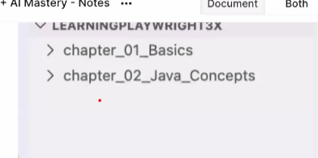

https://app.thetestingacademy.com/student/dashboard
https://app.eraser.io/workspace/9yp9hyBp2Yk4Z5TK4UFB?origin=share
https://app.thetestingacademy.com/student/playwright
https://www.sdetclub.com/c/playwright-3x/task-7th-july-2026-task-1-setup
https://www.sdetclub.com/c/playwright-3x/doubt-7th-july-2026-js-basics-part-1

https://app.eraser.io/workspace/9yp9hyBp2Yk4Z5TK4UFB?origin=share

https://www.sdetclub.com/c/playwright-3x/doubt-7th-july-2026-js-basics-part-1 doubt thread

QATester2000
https://github.com/QATester2000/LearnPlayWright Github Reositoty
https://github.com/QATester2000

